***How to add and commit java files from Git command line***

Precondition: Project should have added into remote git repository

Step 1: Create any new class in eclipse.

Step 2: Now navigate to git repository for this project

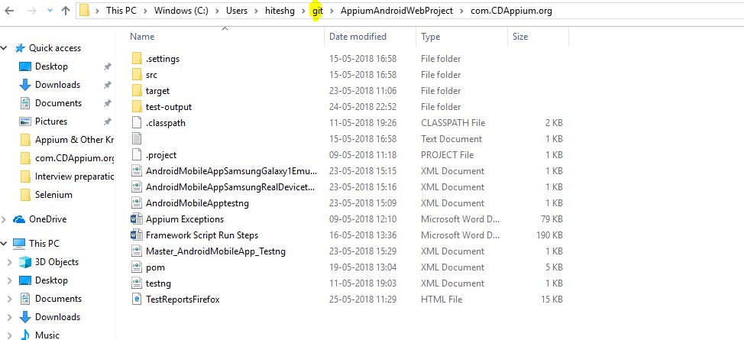

Step 3: Now open the command line for this location

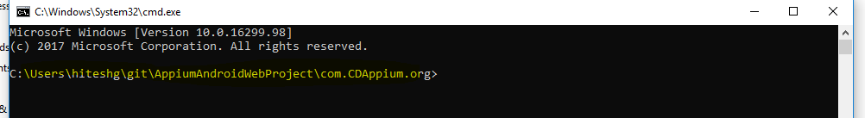

Step 4: Issue ‘ git add *.java’



Step 5: Now commit this

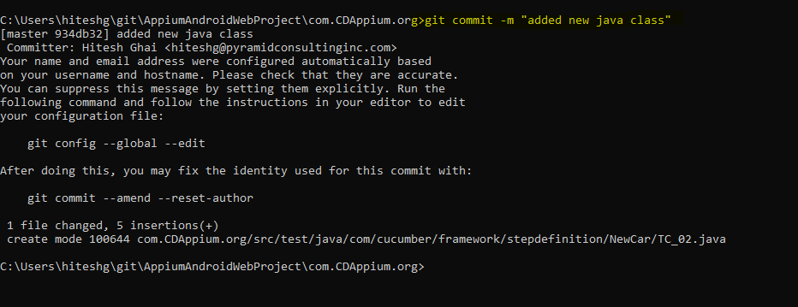

Step 6: Check the file status in eclipse. Currently, it is committed into local repository

